
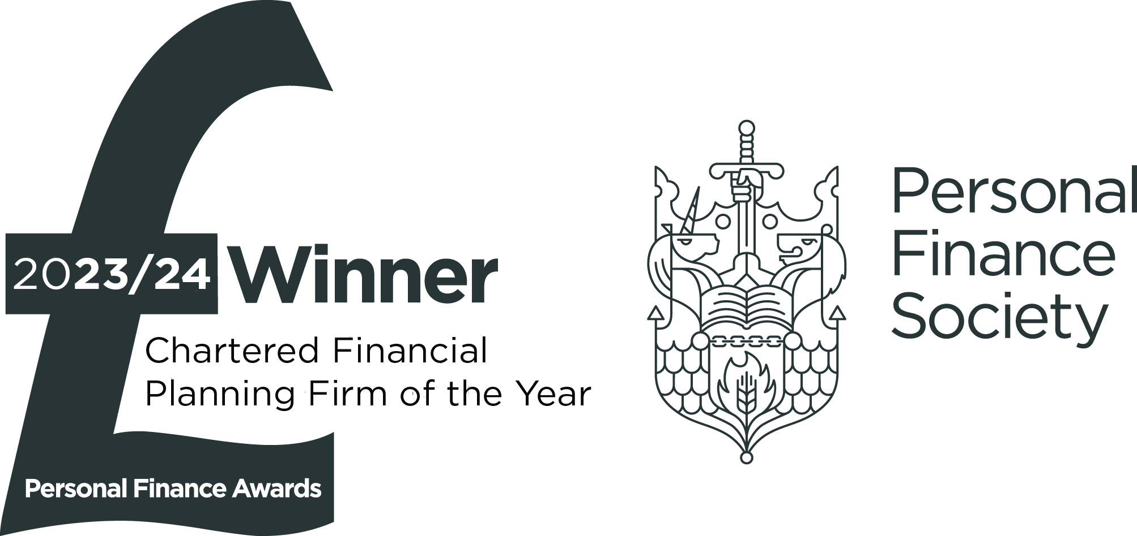
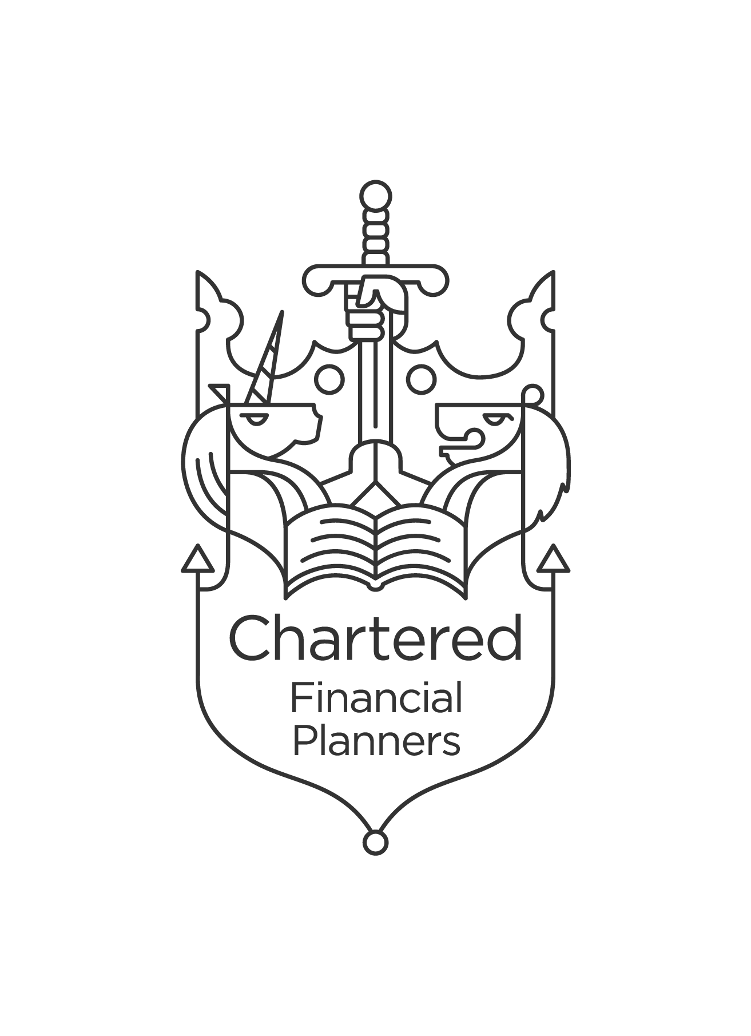


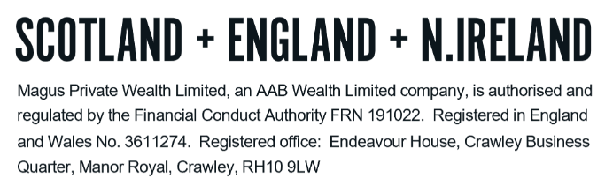
TECHNICAL NOTES – DRAWDOWN

This is the name that describes the payment of pension income through ‘drawdown’ after age 55. Benefits can be taken from age 55 (increasing to age 57 by 6th April 2028) and can remain in drawdown indefinitely. This is also known as flexi-access drawdown (“FAD”).

Utilising drawdown means that you can delay buying an annuity until you are ready to commit to the purchase, potentially deferring it forever.

On entering a drawdown pension arrangement, any tax-free cash, up to a maximum of 25% of the fund value, (known as pension commencement lump sum, or PCLS) must be taken at outset, whether in full or in part, and you can then choose to draw a taxable income from your invested pension fund.

Income drawdown is an option under personal pensions (including self-invested personal pensions) and some types of employer pension scheme. However, if you are a member of an employer’s scheme that does not offer income drawdown, you must first transfer your pensions rights from the employer’s scheme to a personal pension to take advantage of this facility.

Drawdown is primarily suitable for more sophisticated investors with large pension funds who have the capacity to accept the risks that selecting drawdown inherently entails. There are no ‘hard and fast rules’ but, as a guide, the FCA have indicated that drawdown (whether full drawdown or phased drawdown) will normally only be suitable for investors who have funds of at least £100,000, after the PCLS has been drawn.

Funds remaining invested in the stock market are exposed to market fluctuations and can go down as well as up. Provided you understand these risks and feel comfortable with them, there are several reasons for considering income drawdown:

- You want the flexibility to vary the amount of pension income you take. Maybe you need the cash lump sum but have little immediate need for income, or perhaps you are retiring gradually and need a flexible income.

- Estate planning benefits: Funds in a pension are outside your estate for inheritance tax purposes. Due to the changes in the Lifetime Allowance, funds can be left entirely tax-free on death before age 75 unless they are left as a lump sum benefit (and even then it is only the value above the allowance which is subject to tax at the beneficiary’s marginal income tax rate). For pensions left on death after 75, the whole fund is taxable at the beneficiaries marginal rates of tax which with planning can be less than the equivalent Inheritance Tax rate.

- The Government is however in the process of bringing legislation that will make defined contribution pensions funds part of the estate for inheritance tax purposes from 6th April 2027.

- You want to avoid being locked into current annuity rates, although it should always be borne in mind that future annuity rates could fall.

The main considerations are:

- The first 25% is tax-free (within the lump sum allowance); anything after that will be added to other income in the tax year it is received, and income tax deducted accordingly.

- After accessing the taxable income of a drawdown policy, an alternative annual allowance known as the money purchase annual allowance (“MPAA”) will be applied limiting future contributions to £10,000 gross per annum. This means the concept of a pension as a ‘bank account’ is not an appropriate one; for the most part, once funds are taken out of the tax advantageous pension environment, they will not be able to be replaced.

- An individual drawing down and spending all of their personal pension savings will be left with only the State Pension as a source of income, and this is likely to be insufficient for many people. Managing the income stream in retirement is therefore very important.
- Currently, funds within the pension environment are also usually protected from inheritance tax (“IHT”) and so the loss of this is another factor to bear in mind when considering removing funds out of a pension. This factor will however become redundant from April 2027 if the Government do introduce IHT to pensions as expected.

Drawdown and Death benefits

The member of the pension can nominate a beneficiary (or any number of beneficiaries) to receive the value of their pension fund on their death. This can be provided to the beneficiary(ies) via:

- A lifetime income (annuity)
- A drawdown pension (a nominee or successor drawdown pension)
- A lump sum

Although the member is able to nominate their beneficiaries, the administrators of the scheme ultimately have discretion as to how death benefits are paid. While they can, in theory, choose to ignore the nomination, they will in practice pay out death benefits according to this nomination.

There is no distinction in the hands of the beneficiary over whether a pension is crystallised or uncrystallised, and the tax treatment of withdrawals or payments made to the beneficiary are based on three factors:

- Whether the distribution is in the form of a lump sum, a drawdown pension or an annuity pension.
- If the funds are paid out inside a two-year period of death (or two-years of when death was known).
- Whether the member was under 75 at the time.

The following tables show how these factors influence the tax treatment:

If the member dies before age 75:

 | Paid as a lump sum | Paid as a drawdown pension | Paid as an annuity
Paid within two years | Tax-free if within the available LSDBA | Tax-free | Tax-free
Paid after two years | Taxable at the recipient’s marginal rate of income tax

If the member dies after age 75:

 | Paid as a lump sum | Paid as a drawdown pension | Paid as an annuity
Paid within two years | Taxable at the recipient’s marginal rate of income tax
Paid after two years | Taxable at the recipient’s marginal rate of income tax

If the death benefits above are subject to tax at the recipient’s marginal rate of income tax but the recipient is a non-person (i.e. a trust or company) the tax rate applied is 45%.

If no nomination is completed by the members, the scheme administrators will usually seek to pay benefits to any dependents of the member. This type of person is classified as:

- The spouse or civil partner of the member.
- A child under 23 or a child over this age who is dependent due to physical or mental impairment.
- An individual financially dependent on the member. This could be due to physical or mental impairment or it could be a financial relationship (i.e. partners living together sharing finances).

The figures and detail above are around the tax treatment of pension funds based on current pension legislation. The introduction of IHT would be separate and in addition to the above.

NO DEPENDENTS

In the event that there were no dependents on death, the scheme administrators will use their discretion to direct death benefits towards a nominee of their choosing.

This means that the lump sum and/or an income can be paid to:

- Other family members, e.g., adult children
- A trust set up by the deceased
- The deceased’s estate (resulting in the pension being included for IHT purposes)
- The deceased’s friends or business partners
- A charity

For this reason, it is important that the individual nominates who they wish to receive any death benefits.

Drawdown and inheritance tax (“IHT”)

The Finance Bill provides the following exemptions from inheritance tax liability for death benefits paid on death under drawdown:

- In all cases where the benefit is paid to a spouse, civil partner, financial dependent or charity.

- In other cases where the member had no reason to believe that their life expectancy was less than two years when commencing drawdown, and it is clear that deferring benefits was not done with the intention of avoiding IHT charges.

- Where, having deferred the pension as above, the member becomes aware that their life expectancy is less than two years, but they don’t deliberately try to enhance the value of the estate by reducing withdrawals under the plan.

The above is however expected to change from 6th April 2027 as the Government introduces legislation making defined contribution pensions part of the estate for IHT purposes.

Advantages of drawdown

- You will be able to take the maximum (or lower amount) of tax-free cash lump sum immediately to spend or invest without having to convert the rest of the fund to an annuity.

- Under FAD, there is no cap on the amount of income that can be drawn.

- Flexible income – you may choose to take any level of income that you require, whether it be a regular income or on an ad hoc basis.

- You will be able to plan in advance the level of income that you wish to take each year, so that you can take into account any other sources of income that may be available to you.

- The pension fund (less any income withdrawn and associated charges) will continue to be invested in a tax efficient environment until you decide to purchase an annuity or continue drawdown.

- You can structure your income to mitigate your liability to Income Tax. For example, by reducing drawdown income in some tax years, you may be able to avoid a higher rate tax liability.

- There are flexible options on death. The death benefits payable may be greater than under the conventional annuity route, particularly since the death tax charge was removed.

- As you get older there is the prospect of annuity rates rising and therefore providing a higher income. This is because it is cheaper for insurance companies to purchase an annuity to provide a given level of income for someone aged, say 70, than someone aged 60.

Disadvantages of drawdown

- A careful investment portfolio needs to be drawn up which will involve investment risk and a reliance upon investment management.

- A minimum level of growth must be achieved by the remaining pension fund in drawdown, in order to maintain its value after the income payments have been taken (assuming an income is taken of course). If this ‘critical yield’ is not achieved the fund may be unable to purchase an annuity equivalent to that which could have been purchased at outset if income withdrawals had not been selected.

- Should a high level of income be taken, unless there is exceptional growth, the withdrawals will not be sustainable during the deferral period.

- Deferment of the purchase of an annuity may result in less favourable annuity rates if and when a purchase is eventually made.

- If the expected changes to pensions and IHT happen from 2027, there is a risk of your pension being subject to IHT by remaining in drawdown as opposed to purchasing an annuity (which can provide a spouse pension outside the scope of IHT).

- In addition, the investment fund may be depleted, either through investment performance or withdrawals, to the extent that even if current annuity rates are maintained, the annuity that can be purchased in the future will drop.

- Annuity providers make a profit from the fact that some individuals die sooner than is expected and use some of this ‘mortality profit’ to enhance current annuity rates. By delaying the purchase of your annuity, the benefit of this potential profit, which can be significant, may be lost.
- It is important to keep your drawdown pension and the amount of income you are taking under regular review.

- The ongoing charges associated with a drawdown account will affect the net growth rates.

DO NOT REMOVE THIS LINE – DELETE THE TEXT ONLY

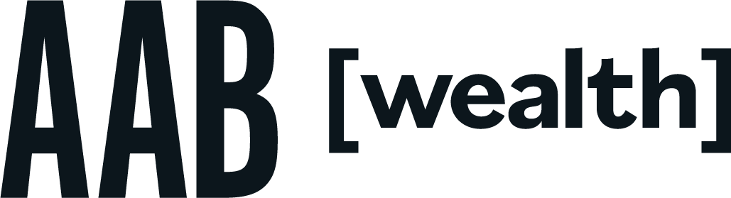
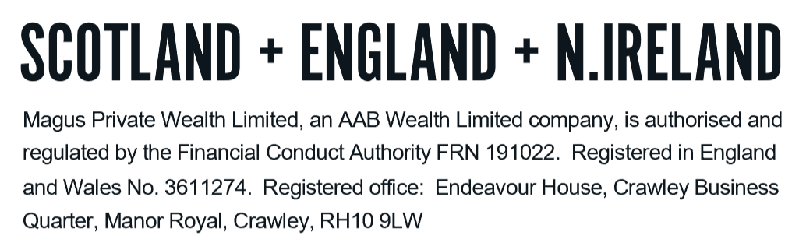
Tel: +44 (0)203 176 5888
magus.servicing@aabwealth.uk
www.aabwealth.uk

