
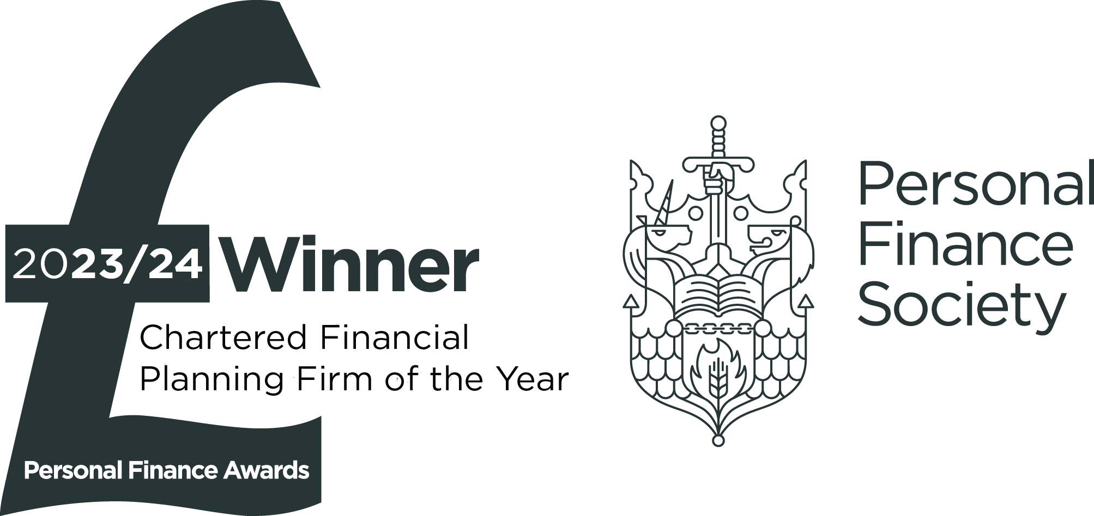
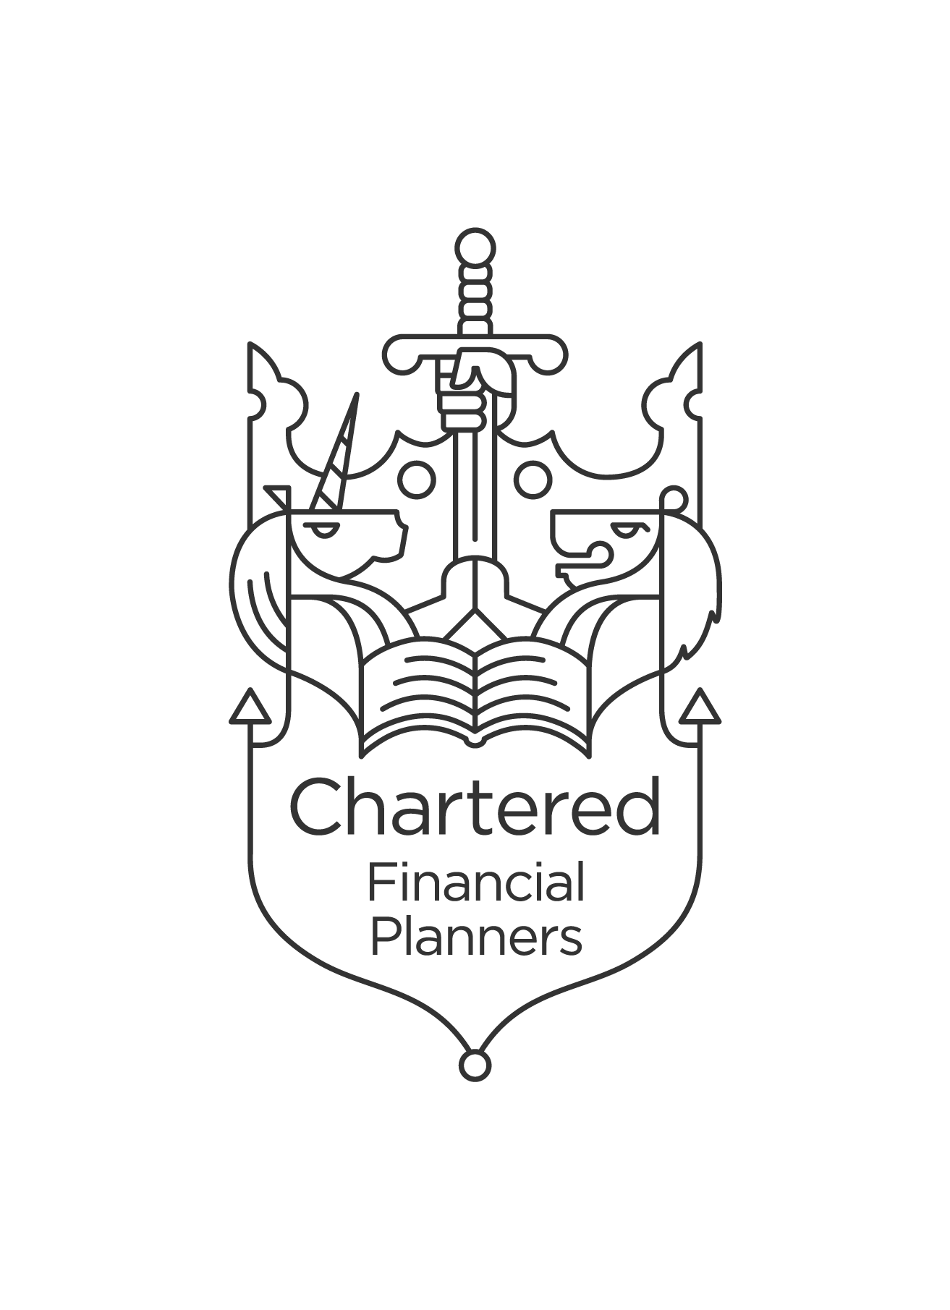


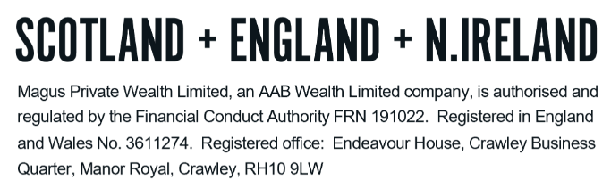
TECHNICAL NOTES – RETIREMENT OPTIONS

There are a variety of ways in which retirement benefits can be taken. The main ones are as follows:

- Annuity purchase
- Defined Benefit / Scheme Pension
- Flexi Access Drawdown (or continuing Capped Drawdown for existing schemes)
- Uncrystallised Funds Pension Lump Sum (“UFPLS”)

Where available, it is possible to use a combination of these retirement strategies. A summary of the main ones can be found in this guide.

Annuity purchase

The primary feature of an annuity is the ability to receive up to 25% of the fund value as tax-free cash and use the remaining balance to purchase a guaranteed level of income, which will be paid for the rest of your life.

There are various features that can be built into this, such as escalating income, but the main feature is the use of your pension fund to purchase an income for life. The income is based on the value of the pension fund and annuity rates at the time of purchase. Any additional features will affect the annuity rate. There is usually no option to vary the features of the annuity.

Once this has been entered into it cannot be changed and an income would be paid for the rest of your life. Unless you purchase a guarantee or a spouse’s pension, the annuity would cease on your death. Therefore, if you were to die in the early years of purchasing an annuity, you would not have received back as much as was used to purchase the annuity, and nothing would be paid out on your death. Conversely if you were to live for many years, the annuity purchase could prove to be very good value for money.

There are alternatives to a lifetime annuity, called fixed term annuities. These are designed to run for a certain period of time with a capital value returned at the end of the term. For legal purposes, a fixed term annuity is deemed as a Drawdown product.

Defined Benefit / Scheme Pension

These are structured similarly to annuities in that a lifetime income is provided, with the pension unable to be altered at a later date. These are provided by a sponsoring employer rather than purchased through an insurer. The amount of income is based on your length of service and salary with your sponsoring employer.

It is possible to transfer entitlement to a defined benefit pension to a defined contribution pension by accepting a Cash Equivalent Transfer Value (“CETV”) from the scheme. In the vast majority of circumstances, the value of a defined benefit pension is such that the CETV is likely to offer poor value compared to the defined benefit pension.

Flexi-access drawdown (“FAD”) and uncrystallised funds pension lump sum (“UFPLS”)

UFPLS is the option for plans that do not offer drawdown. It allows an individual to take a lump sum from their pension; 25% of this will be tax-free (providing it is within your Lump Sum Allowance) and the remaining 75% will be added to their taxable income in that year and taxed accordingly.

FAD enables an individual to take up to 25% of their fund free of any taxes (within the Lump Sum Allowance) and the balance can be drawn as they require; it is not necessary to take it all as a lump sum as is the case with UFPLS. With FAD there is no limit to the amount that can be withdrawn, but again it will be added to the individual’s taxable income in that year and taxed accordingly.

If an individual accesses either FAD and takes income or UFPLS, there is a reduction in the level of future pension contributions they are able to make. Either of these options results in the member being subject to the money purchase annual allowance (“MPAA”) of £10,000; this therefore being the maximum gross contribution they can make in a tax year. The ability to carry forward unused allowances is also lost.

Prior to 6th April 2015, ‘capped drawdown’ was the most frequent used form of drawdown. These have a limit on the amount of income that can be drawn each year, with the limit reviewed every three years. The minimum can still be set at £0. Clients who were in capped drawdown prior to 6th April 2015 have retained access to the standard annual allowance which is currently £60,000. If you have a Capped Drawdown plan open it is possible to take any future benefits using Capped Drawdown rather than FAD.

With drawdown, your funds remain invested and so the value of your pension can both rise and fall. If you die before age 75 and if the benefits are distributed within two years, your beneficiaries can receive a return of your remaining funds without any tax being payable. This is based on the funds passing to the beneficiaries as a dependent/nominee drawdown pension (or a nominee/dependent annuity).

If funds are instead designated as a lump sum there is a Lump Sum and Death Benefit Allowance (“LSDBA”) which restricts the amount that can be passed tax-free. There is further information on the LSDBA in the Technical Notes – Pensions document.

If you die after age 75 then the pension will be taxable at your beneficiaries’ marginal rates. This is the case regardless of whether the funds are passed on as a drawdown pension, an annuity or as a lump sum.

In addition to the above, defined contribution pension funds are scheduled to be included in the estate for inheritance tax purposes from 6th April 2027. The Government are currently in the process of legislating for this to happen.

DO NOT REMOVE THIS LINE – DELETE THE TEXT ONLY


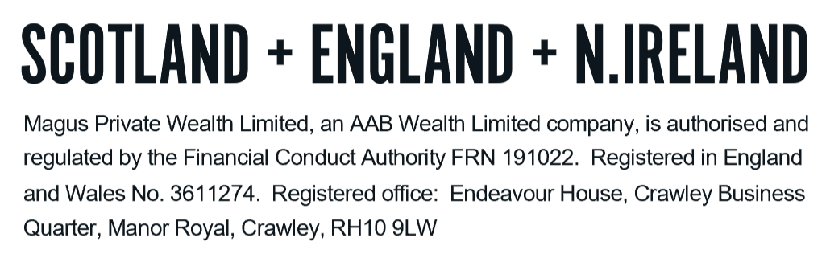
Tel: +44 (0)203 176 5888
magus.servicing@aabwealth.uk
www.aabwealth.uk

