
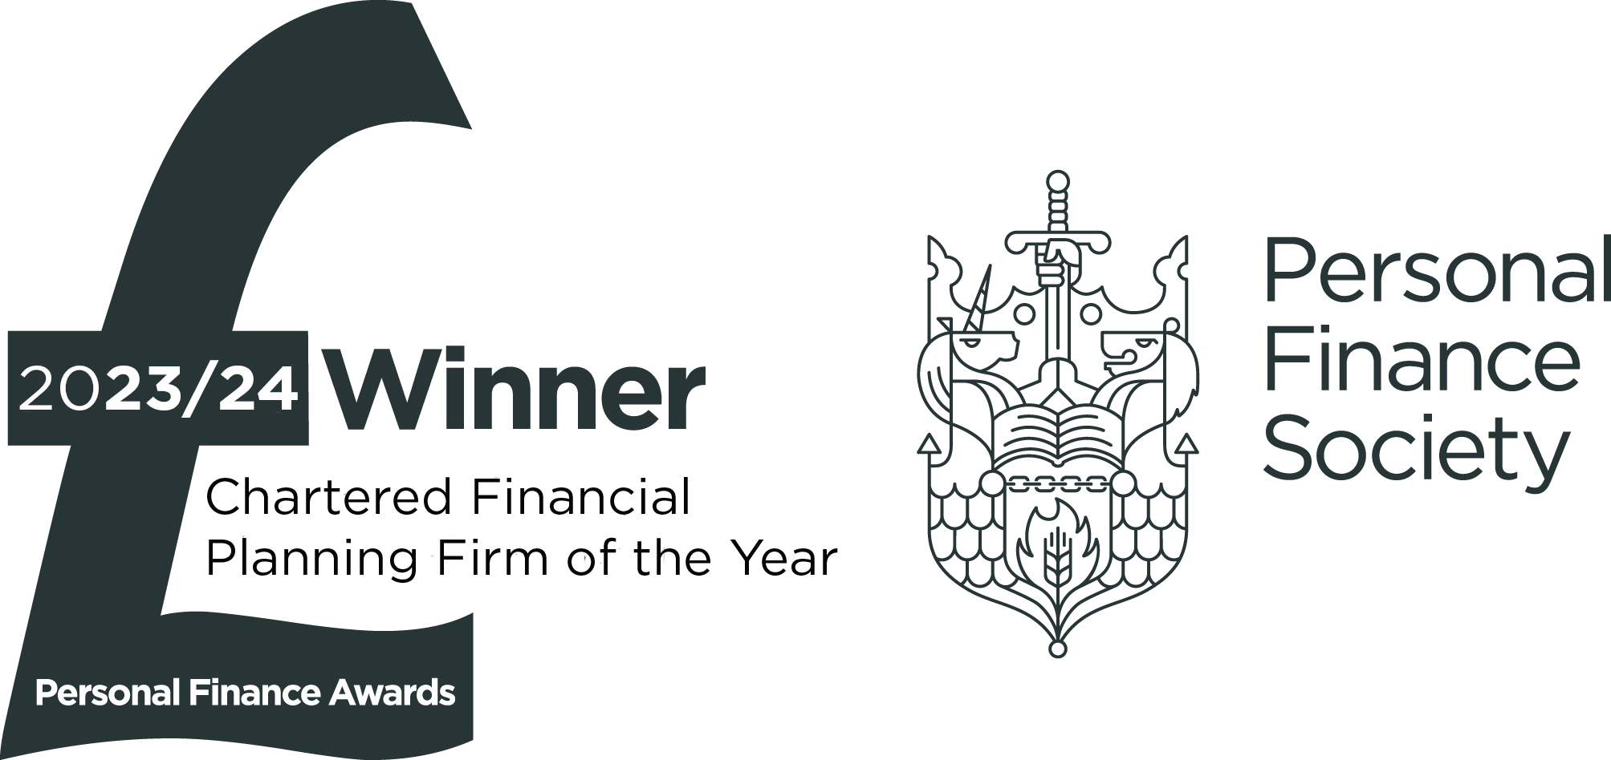

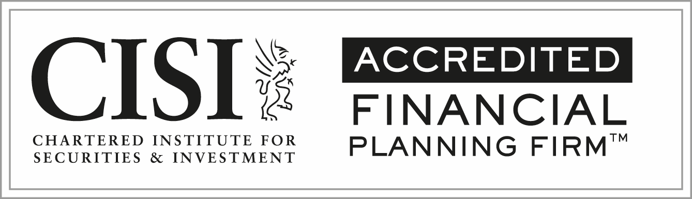

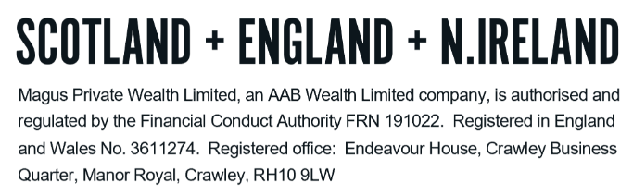
TECHNICAL NOTES – PENSIONS

TAX RELIEF

Tax relief is granted on personal contributions subject to the greater of:

- £3,600 per annum; and
- 100% of relevant earnings (salary, bonuses and benefits in kind)

These limits are subject to the annual allowance detailed further on.

To benefit from tax relief on contributions up to age 75, you need to be resident in the UK, or be a Crown Servant serving overseas, or their husband, wife or civil partner. Contributions are paid net of basic rate income tax with the relief claimed from the Treasury by the pension administrator. Higher rate taxpayers can claim further relief on their contributions through the self-assessment process.

Contributions paid by a company on behalf of an individual (employer’s contributions) are tax relievable against the companies’ profits. There are no implications on the individual’s personal income tax. However, the contributions are still subject to annual limits and must be justifiable in accordance with the individual’s income in order to be tax relievable.

Tax advantages

Some of the benefits of contributing to a pension scheme are:

- Capital gains within the fund are tax-free.
- Income generated within the fund is free of tax.
- Currently 25% of the fund (subject to a lifetime maximum of £268,275) can be taken tax-free on retirement.
- Lump sum death benefits are normally paid free of inheritance tax.
- The Government are in the process of introducing legislation to bring defined contribution pension funds into inheritance tax (from 6th April 2027).

Considerations

- It is not possible to access the fund before age 55 (increasing to 57 in 2028) and it is not suitable for short-term savings or where there may be a need to access the entire fund as a lump sum.

- With a personal pension you can take benefits without the need to retire from work.

- You can increase contributions (subject to certain limits), add a single contribution or add a transfer payment (from a previous pension plan) at any time.

Lump Sum Allowance

The Lump Sum Allowance (“LSA”) is a lifetime limit on the amount of Pension Commencement Lump Sum (“PCLS”) that can be taken from one or various pension schemes.

It was introduced on 6th April 2024 and is set at the lower of 25% of your fund value or £268,275. If an individual holds a valid form of Lifetime Allowance (“LTA”) protection that would have provided entitlement to a higher level of PCLS under the former LTA rules, they are able to retain this as a higher LSA.

Lump Sum and Death Benefit Allowance

The Lump Sum and Death Benefit Allowance (“LSDBA”) represents a limit on the amount of lump sum death benefits that can be left tax-free on death before the age of 75. This assumes the payments are made within a two-year window of death. If this is not the case, the payments are subject to tax at the beneficiary’s marginal rate.

The LSDBA was also introduced on 6th April 2024 and set at £1,073,100. This limit is only reduced during the individual’s lifetime by the amount of LSA they have taken and so for those who take the maximum LSA of £268,275, the remaining LSDBA is £804,825. This allowance can again be increased if individuals hold a valid LTA protection.

Any funds left as a lump sum on death (before age 75) that exceed the LSDBA are subject to tax at the recipient’s marginal rate of income tax.

The LSDBA only applies where an individual is leaving pension benefits on death in the form of a lump sum payment. Any benefits left in the form of a beneficiary’s or dependent’s drawdown plan is not subject to the LSDBA test.

Once the age of 75 is reached, all pension benefits left on death (whether lump sum or under drawdown) are subject to tax at the recipient’s marginal rate of income tax.

If the beneficiary does not have a personal tax rate, e.g., a trust or company, then a rate of 45% will apply.

It is therefore critical that a nomination of beneficiary form is completed to ensure they pass to the right person.

Contributions

There are no restrictions on the amount you can pay into a pension. There is however an annual allowance which if exceeded results in a tax charge applied on the excess. The effect of this is to remove the tax benefits of contributing to a pension once a certain contribution level (the annual allowance) is exceeded.

The annual allowance

The annual allowance is the amount that can be saved into a pension each year. If the allowance is exceeded (and if carry forward is not used) an individual becomes subject to an income tax charge on the excess. This tax charge is applied to the individual even if it is employer contributions that exceed the allowance.

The standard annual allowance is currently £60,000 and has been at this level since 6th April 2023. For personal payments up to £60,000, income tax relief is available (subject to the gross contribution not exceeding 100% of relevant earnings); this includes individuals who are taxed at 45%.

There is the opportunity to carry forward unused annual allowances from earlier years. The annual allowance will be reduced so that for every £2 of income over £260,000, the annual allowance is reduced by £1. The maximum reduction will be £50,000, so anyone with income of £360,000 or more will have an annual allowance of £10,000.

Money purchase annual allowance (“MPAA”)

A further reduction to the annual allowance applies and this is targeted at individuals who have flexibly accessed their pension rights. Flexibly accessed includes taking an income under flexi-access drawdown or purchase of a fixed term annuity. It does not include taking only the tax-free cash from a pension, purchasing an annuity or putting into payment a defined benefit scheme pension. The MPAA restricts future annual contributions to £10,000 gross. It is not possible to carry forward any unused MPAA.

An individual who flexibly accesses their pensions is obligated to tell all other remaining pension providers they are subject to the MPAA within 91 days of accessing benefits flexibility. Failure to notify the other providers in this time can incur a £300 fine and a daily penalty of £60 for every day after the initial 91 days.

State pension age (“SPA”)

The SPA is the earliest age you can draw your State Pension. Your SPA is specific to your date of birth.

The age in which individuals became entitled to State Pension rose to age 66 from October 2020. It is in the process of increasing to 67 (affecting those born after 6th March 1961) and there are further plans to increase the age to 68 though these are not finalised in legislation as to when they will happen.

Accessing pensions

The three main ways in which a pension can be accessed are:

- To purchase a lifetime annuity
- Flexi Access Drawdown (“FAD”)
- One or more Uncrystallised Funds Pension Lump Sum (“UFPLS”)

Under both the FAD and UFPLS options, there is no limit on the amount that can be taken at once or in any one year. The only limit is the value of the fund (and any access restrictions applied by the pension provider).

The first 25% of any withdrawal under FAD or UFPLS is tax free with any withdrawal above this amount added to an individual’s other income in that tax year and taxed accordingly.

Entitlement to 25% of the fund as a tax-free lump sum is subject to a lifetime limit on tax-free cash known as the LSA.

Once either a taxable income is taken under FAD, or UFPLS used in any capacity, the individual has been deemed to have ‘accessed their pension flexibly’. The individual’s annual allowance for future pension contributions drops to £10,000, preventing funds from being re-accumulated within the pension to a significant degree.

Although there is a significant level of flexibility with how pensions can be accessed, there are a number of important considerations. The main consideration is around sustainability. Individuals have more responsibility around ensuring retirement savings last throughout retirement. With no real restrictions on access there can be greater temptation to take more than what can be sustained through investment returns, or more income may be taken under the assumption that less will be needed later in life.

The individual has to juggle sustainability, the impact of investment returns on funds and tax considerations.

Defined benefits

A defined benefit pension plan is a type of pension plan in which an employer/sponsor promises a specified monthly benefit on retirement that is predetermined by a formula based on the employee’s earnings history, tenure of service and age.

This contrasts with a money purchase pension (such as a personal pension or a stakeholder) in which a fund is built up from contributions and investment growth, and that fund is used to provide an income in retirement.

As a defined benefit plan provides a guaranteed income in retirement, and this typically increases each year, this is a very valuable plan type; money purchase pensions do not offer guaranteed income, although they do offer certain options and flexibility, which defined benefits schemes generally do not offer. Additionally, a defined benefit pension entitlement is not dependent on the performance of the stock market and the funds are protected by the Pension Protection Fund, in the event the employer becomes insolvent.

Reviewing the options with regards to a defined benefits plan, in particular considering transferring it to a money purchase plan is therefore not straightforward; the two plans offer very different benefit structures and all the features and options available between them need to be considered carefully.

Guaranteed minimum pension (“GMP”)

A GMP is a benefit that occupational pension schemes had to provide to individuals who were contracted out of the State earnings-related pension scheme (“SERPS”) between 6th April 1978 and 5th April 1997.

The decision to be contracted out was taken by the employer, rather than the employee, and any schemes which contracted employees out of SERPS had to provide a broadly equivalent pension to what they would have otherwise received.

Self- invested personal pension (“SIPP”)

A SIPP is a type of personal pension plan. It works in the same way for contributions, tax relief and eligibility however, the main difference is the SIPP has a more flexible approach to investments.

A conventional personal pension generally involves the plan holder paying money to an insurance company for investment in an insurance policy. This means the money is invested with relatively little choice or freedom from the plan holder.

A SIPP is a type of personal pension which allows the plan holder much greater freedom in what to invest in, and for the plan to hold these investments directly. The plan holder can have control over the investment strategy or can appoint a fund manager or stockbroker to manage the investments.

Personal pension or SIPP via a platform or wrap

Personal pensions and SIPPs can be held and managed on a ‘platform’ or ‘wrap’ account. These plans work in the same way in terms of legislation around contributions and tax treatment.

Whether termed by the platform/wrap provider as a personal pension or a SIPP (or a ‘hybrid’), these pensions generally have the flexibility of SIPPs and typically afford the following features:

- Access to, in many cases, thousands of investment funds across the market.
- Access to alternative investment options such as exchange traded funds (“ETFs”) and direct equities.
- Full post-retirement flexibility in how benefits are drawn.
- The ability to hold the pension alongside investment wrappers and, in some cases, considered alongside other family member’s accounts to determine the charges applied.

These pensions are typically limited in that they do not offer access to all investment options, with notable exclusions being direct commercial property purchase and unlisted equity investments.

A great deal of innovation in the platform space has occurred over the years, and this has allowed a number of providers to offer increasingly flexible pensions with the cost being driven down through technology efficiencies and competition.

Platforms and wraps

Platforms and wraps are internet-based systems, which allow an adviser to have custody/viewing over a client’s assets, so they can view and administer investments. The platforms/wraps provide advisers with tools to analyse a client’s portfolio, choose products for them and arrange transactions. In some cases, the platform/wrap can be used by the client too for viewing holdings. The main benefits of a wrap are:

- Ease of transactions
- Reduced administration
- Control
- Enhanced fund choice
- Online access
- Cost and economies of scale

DO NOT REMOVE THIS LINE – DELETE THE TEXT ONLY

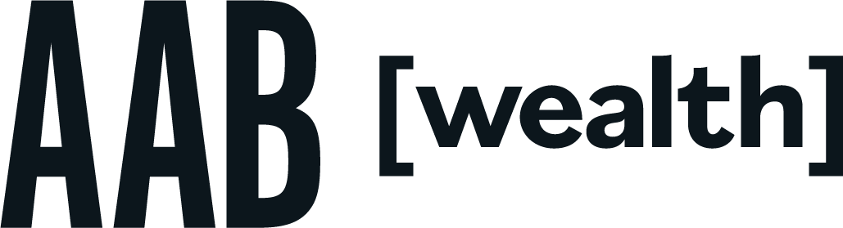
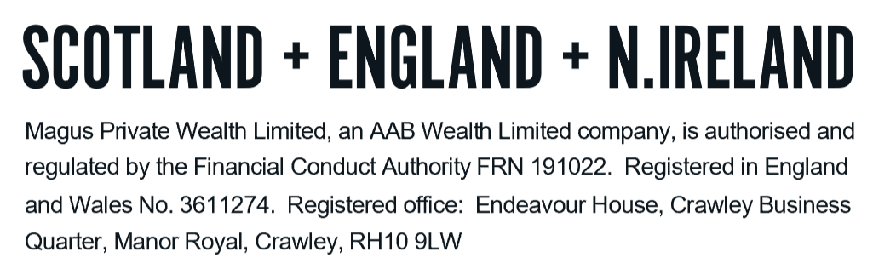
Tel: +44 (0)203 176 5888
magus.servicing@aabwealth.uk
www.aabwealth.uk

