





TECHNICAL NOTES – LIFE COVER

Life cover provides a lump sum in the event of your premature death which, when invested, can provide long-term security for your beneficiaries.

Life cover and critical illness cover can be written as term or whole of life policies. Term assurance provides protection for a pre-specified term and is therefore particularly useful for covering a specific debt or period, e.g., a mortgage or until children have left home. Whole of life policies are designed to provide protection throughout your life.

For each type of policy, the premiums and cover can be structured in a number of different ways.

Term assurance

The options with term assurance are:

Level cover
- Under this plan the sum assured remains the same for the duration of the contract.

Increasing cover
- Indexing your sum assured allows you to maintain the real value of your life assurance protection as it increases automatically each year, regardless of your state of health at that time. Your premium will also increase each year to reflect the increase in the sum assured although the proportional increase can be expected to be higher. For example, if the sum assured is increasing by 5% then the total premium may increase by slightly more than 5%. This is because the part of the new premium which relates to the increase in benefit, will be based on your age attained rather than your age at the time your contract commenced.

Convertible cover
- Under this plan the sum assured remains the same for the duration of the contract. An extra payment is made to allow the policyholder an option to convert the original policy (or part of it) to another type of policy - increasing term assurance, whole of life or endowment - without further medical evidence being required.

Decreasing cover
- Under this plan the sum assured is specified at the outset of the contract and decreases throughout its term.

Mortgage protection
- Under this plan the sum assured is specified at the outset of the contract and cover decreases throughout the policy term. The decrease in sum assured will be broadly in line with the reducing mortgage debt.

Reviewable cover
- Under this plan the sum assured remains the same for the duration of the contract. Premiums are kept to a minimum as you, rather than the insurance company, are shouldering the risk of changes in mortality experience. The insurer has the right to review premiums based on claims history, which could mean premiums increase significantly at a review.

Renewable cover
- Under this plan the sum assured remains the same for the duration of the contract. For a higher premium you acquire the option of extending the original term of the policy, without having to provide medical evidence.

Family income benefit
- Similar to term assurance, the benefit is payable should death occur within a specified term. Whereas the benefit provided under term assurance is in the form of a lump sum, a family income benefit plan will pay regular payments to your dependants until the end of the term. This benefit can be level or increasing. The income payable from such a policy is treated as capital and would be tax-free under current legislation.

Whole of life

Whole of life assurance is designed to pay out a cash lump sum on your death or critical illness depending on the type of policy chosen. The main advantage of a whole of life assurance policy is that it is capable of providing life assurance and critical illness cover for the entire period of your life, regardless of when you die or are diagnosed with one of the defined critical illnesses. Your application is underwritten when you apply for cover and the premium is therefore based on your state of health at this time. Should your health subsequently deteriorate the premium is not affected.

In view of this, whole of life policies will generally involve a higher outlay than term assurance contracts – contracts that are for a chosen specific period of years.

The options with whole of life policies are typically:

- Standard or balanced cover provides a sum assured at an initial premium that the insurance company believes can maintain the sum assured throughout your life, assuming the investment fund grows at a given growth rate. If this default investment return is maintained during each review period the amount of cover should be maintained. Should investment returns fall below this level however, you will need to either increase your premium or reduce your sum assured.

- Maximum cover provides an initial sum assured at the lowest level of initial premium that the insurance company is willing to accept to provide the desired sum assured. The sum assured is guaranteed until the first plan review, typically after 10 years. At that point, either the sum assured will reduce significantly or, if you wish to maintain the same level of cover, the premium will increase significantly to take into account your then current age. Although this type of cover costs less than standard cover, the increase in premium at the first review is likely to be substantial.

With all types of whole of life plan, you can opt for the sum assured to be increased at regular intervals (usually yearly) on a pre-determined basis, irrespective of any changes in your health since the policy starts. The pre-determined basis may be a link to an index, such as the Retail Prices Index or National Average Earnings Index, or at a fixed percentage rate.

DO NOT REMOVE THIS LINE – DELETE THE TEXT ONLY


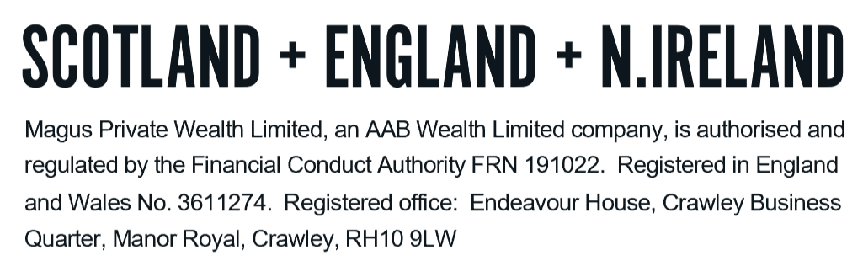
Tel: +44 (0)203 176 5888
magus.servicing@aabwealth.uk
www.aabwealth.uk

