




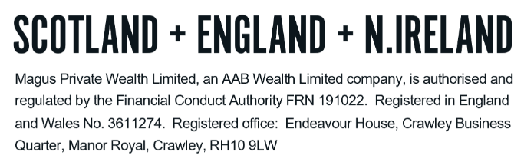
TECHNICAL NOTES – INVESTMENT BONDS

Investment bonds are long term investment contracts with a minimal life assurance element and can be used either to accumulate a growing capital fund for use in the future, or to provide a tax-efficient income which can be taken on a regular basis.

Your investment is a unit linked investment where the value of your units can fall as well as rise. Your capital will be pooled together with the capital from other investors, and this will be invested by professional fund managers into equities, fixed interest stocks, property and cash deposits.

The primary aim of this investment is to provide steady capital growth, which is in excess of that which could be achieved in a bank or building society. The most significant factor affecting the ultimate investment return is how well the fund performs. This fund will be managed for you by a professional fund manager.

A bond is intended as a long-term investment and therefore requires sufficient time to grow. Should you withdraw your investment during the early years of the plan (typically within the first 5 years) you may not get back the full amount invested.

Whilst bonds are similar in function to collective investments there are key differences, particularly in the way they are taxed:

- Investment bond chargeable gains are subject to income tax
- Collective investments are subject to capital gains tax (“CGT”) on capital growth
- Offshore bonds benefit from ‘gross roll up’ (explained below)
- The first £500 of dividend income from a collective investment is tax free
- There is no CGT on gains following the death of a collective investment holder

ADDITIONAL INVESTMENT BOND ADVANTAGES

- An investment bond can be held in joint names meaning in the event of the death of one of you it can continue in the name of the other, avoiding complication and enforced surrenders at an inappropriate time.

- Withdrawals of up to 5% of the original investment can be taken every year, without having to pay an immediate tax charge.

- They can be used for future inheritance tax (“IHT”) mitigation if gifted into trust, or moved to an IHT product such as a loan trust or discounted gift trust.

- You have the option to assign segments of a bond to beneficiaries, with any tax payable applicable at their highest marginal rate.

- Offshore bonds are issued outside the UK, therefore returns can roll up gross of tax within the fund, and so could grow faster. This is known as ‘gross roll up’.

Onshore and offshore bonds

Investment bonds can be in either the UK or an offshore centre (typically Isle of Man, Jersey or Dublin). The underlying investment is identical regardless of where the bond is held, however it impacts on the tax position of both the underlying investment and for the investor when a ‘chargeable gain’ occurs.

Features

- You can take a regular ‘income’ at any time from the bond (‘income’ is treated as the withdrawal of capital for tax purposes). ‘Income’ of up to 5% of the original investment can be taken each policy year, tax deferred until final surrender or earlier chargeable event. Any 5% allowance not used can be accumulated; however, no more than 100% of the original investment amount can be taken from the bond in this way.

- You decide when to withdraw your investment when it suits your individual circumstances. In this way, the tax impact of withdrawal can be minimised.

- Switches between investments can occur without any immediate tax liability.

- There is no capital gains tax. Any tax liability will be based on your income and the prevailing income tax rates at the time of surrender.

An offshore investment bond can be written either on a life assurance or capital redemption bond basis, as follows:

Life assurance bond

- There is no specific policy term – proceeds are payable on death of the last surviving life assured.

- The amount payable under each segment is the surrender value on the dealing date following receipt of written notification of death, plus £1.

Capital redemption bond

- There are no lives assured, only policyholders
- Each policy has a term of 99 years

Chargeable events

Chargeable events give rise to an assessment over whether a tax charge is payable. The chargeable events are:

- Death of the last life assured (life assured policy only). This is why it is preferable to have more than one life assured and this could be a combination of trustee/beneficiaries.

- Assignment for money or money’s worth.

- Maturity of the policy (if capital redemption).

- Withdrawals in excess of the 5% allowance in any one year or the cumulative 5% allowance (i.e., if no withdrawals are taken in the first 3 years and the individual draws more than 20% in year 4).

- Surrender of individual segments or the bond as a whole.

A chargeable event is not incurred on the following:

- A fund switch within the policy.
- Assignment of the policy to another individual or into trust.
- Withdrawals within 5% of the annual allowance or within the cumulative unused allowance.

When a chargeable event occurs, a certificate will be provided by the bond provider and this needs to be reported on the relevant tax return. The tax treatment of the chargeable event will depend on whether the bond is onshore or offshore.

Order of taxation

Despite the overall similarity between an onshore and offshore investment bond, they fall in different places in regard to the order of taxation.

1. Employment / self-employment income, rental income.
2. Offshore bond gains & savings income.
3. Dividend income.
4. Onshore bond gains.

The main implication of the above is that an onshore bond gain, and the level of tax due, needs to be calculated after totalling employment income, savings income and dividend income.

An offshore bond gain is calculated without including dividend income (though this does mean any dividend income may fall into a higher rate of tax compared to an onshore bond).

Tax on chargeable gains – onshore bonds

Onshore bonds come with a basic rate tax credit and as stated, means an individual does not pay tax unless the gain and other income in the tax year exceed the threshold for higher rate tax.

Top slicing is available to assess the tax rate at which the gain is charged. The total gain is divided by the number of full years the policy has been in force for and this amount is added to an investor’s taxable income for the year.

The tax bracket this puts an investor in (i.e., basic rate/higher rate/additional rate) is the rate in which the whole gain is taxed. If the top-sliced gain straddles two tax brackets, the overall gain is taxed under those brackets proportionally. You may lose your personal allowance if the total gain when added to your total taxable income exceeds £100,000.

Tax on chargeable gains – offshore bonds

Holders of offshore bonds are liable to tax on the full gain, to reflect the fact the bond has not paid any UK tax over the course of the investment.

Top slicing is again available with the same rules applying to both offshore and onshore bonds in this regard. It is possible to use the personal savings allowance for both the top slicing of the gain and the resulting gain. The starter rate for savings allowance is also available to offshore bonds.

DO NOT REMOVE THIS LINE – DELETE THE TEXT ONLY


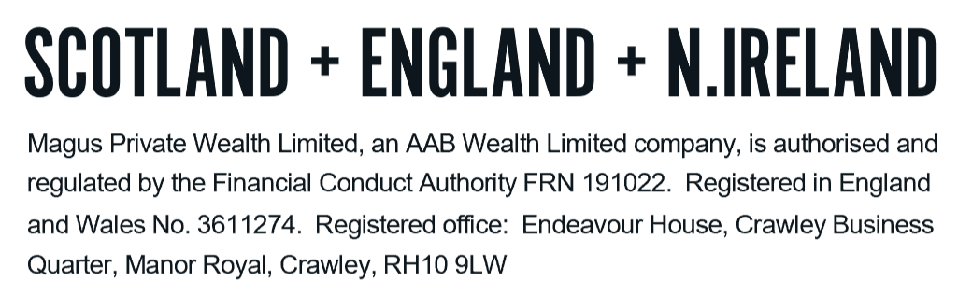
Tel: +44 (0)203 176 5888
magus.servicing@aabwealth.uk
www.aabwealth.uk

