
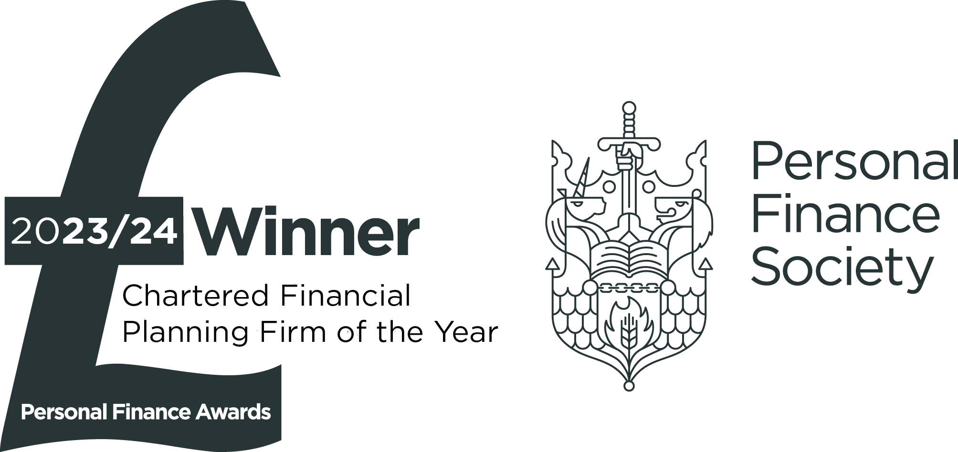



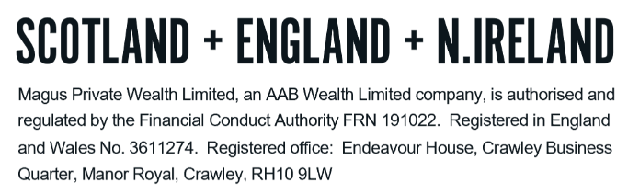
TECHNICAL NOTES – ISAs

What is an ISA?

ISAs offer an attractive tax-free shelter to anyone aged 18 or over. Tax must be paid on the income and profits made from investments in the stock market like company shares or unit trusts. However, ISAs serve as a kind of 'wrapper' to protect savings from tax, allowing individuals to put away a maximum of £20,000 this tax year by way of regular or single savings amounts, in a range of savings and investments and pay no personal tax at all on the income and/or profits received.

Junior ISA (“JISA”)

A JISA is similar to a standard ISA, but designed for children. No tax is payable on interest or investment gains.

A child’s parent or legal guardian must open the Junior ISA account on their behalf. The money in the account belongs to the child, but they cannot withdraw it until they turn 18, apart from in exceptional circumstances. They can, however, start managing their account on their own from age 16. When the child turns 18, their account is automatically rolled over into an adult ISA (sometimes called NISA).

The Junior ISA limit is £9,000 for the tax year 2025/26 If more than this is put into a Junior ISA, the excess is held in a savings account in trust for the child – it cannot be returned to the donor. Parents, friends and family can all save on behalf of the child.

LISA

Lifetime ISAs (also known as LISAs) are a type of ISA created to help people save either for their first home or for retirement. If you take out a Lifetime ISA, the government will give you a bonus worth 25% of what you pay in, up to a set limit, every tax year.

The LISA limit is £4,000 each tax year with this limit shared with the main ISA allowance (meaning an individual can contribute £4,000 to a LISA and £16,000 to another ISA to use their £20,000 allowance).

The main ISA benefits are:

- No personal tax (income or capital gains) on any investments in an ISA
- Income and gains from ISAs do not need to be included in tax returns
- Money can be withdrawn from an ISA at any time without losing the tax breaks

The basics of how ISAs work

A single ISA can hold either of the following:

- stocks and shares, in the form of either individual shares or bonds, or collective investments
- cash, usually containing a bank or building society savings account

Individuals can now hold any amount of their investment in either stocks and shares or cash or a mix of the two. They are also able to transfer money saved in previous years' ISA holdings to a new provider without affecting their current year's allowance. These transfers can be partial or full transfers.

It is also possible to contribute to multiple ISAs in the same tax year, so long as the overall subscription limit is not exceeded.

If the provider facilitates it (through being a ‘flexible ISA’) it is also possible to withdraw from an ISA and replace it within the same tax year, without affecting the annual £20,000 allowance.

Qualifying Investors

To qualify as an eligible investor, you must be resident and ordinarily resident in the UK (or is a Crown servant serving overseas or the spouse of such an individual who accompanies their spouse abroad).

When an individual ceases to be eligible to invest in an ISA, any existing ISAs will continue to be exempt from UK tax, but no further contributions may be made.

ISAs on death

In the event of an ISA holders’ death, a spouse can inherit an Additional Permitted Subscription (“APS”) which is equivalent to the value of the deceased’s ISA at the date of their death. This increases the amount the widowed spouse can invest into their own ISA.

The widowed spouse does not need to inherit the ISA itself to benefit from the allowance and can therefore make use of it whether they inherit the underlying ISA or not. Only a legal spouse can inherit this allowance.

The allowance is available for the later of three years after death or 180 days after the administration of the estate has been completed.

The allowance is the higher of:

- The value of the deceased’s ISA at the date of death.
- The value at the time of account closure (i.e. including any growth from the date of death to the date the allowance is claimed).

Funds in an ISA are generally included in the individual’s estate for the purpose of inheritance tax. The main exception to this is specialist ISA products which invest in assets that qualify for Business Relief (“BR”). These assets are shares traded on the Alternative Investment Market (“AIM”).

Assets held in this are currently fully relieved against inheritance tax, but this status will change to 50% relief from 6th April 2026.

DO NOT REMOVE THIS LINE – DELETE THE TEXT ONLY


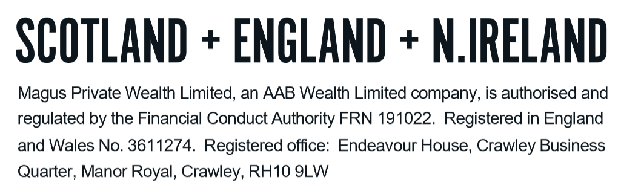
Tel: +44 (0)203 176 5888
magus.servicing@aabwealth.uk
www.aabwealth.uk

