
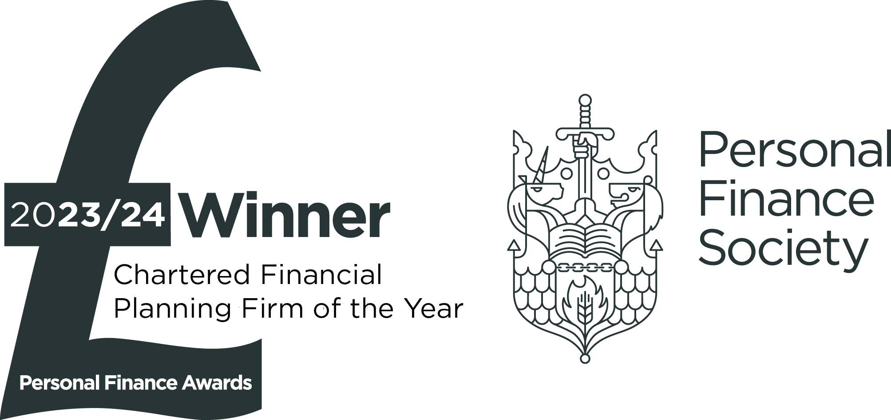
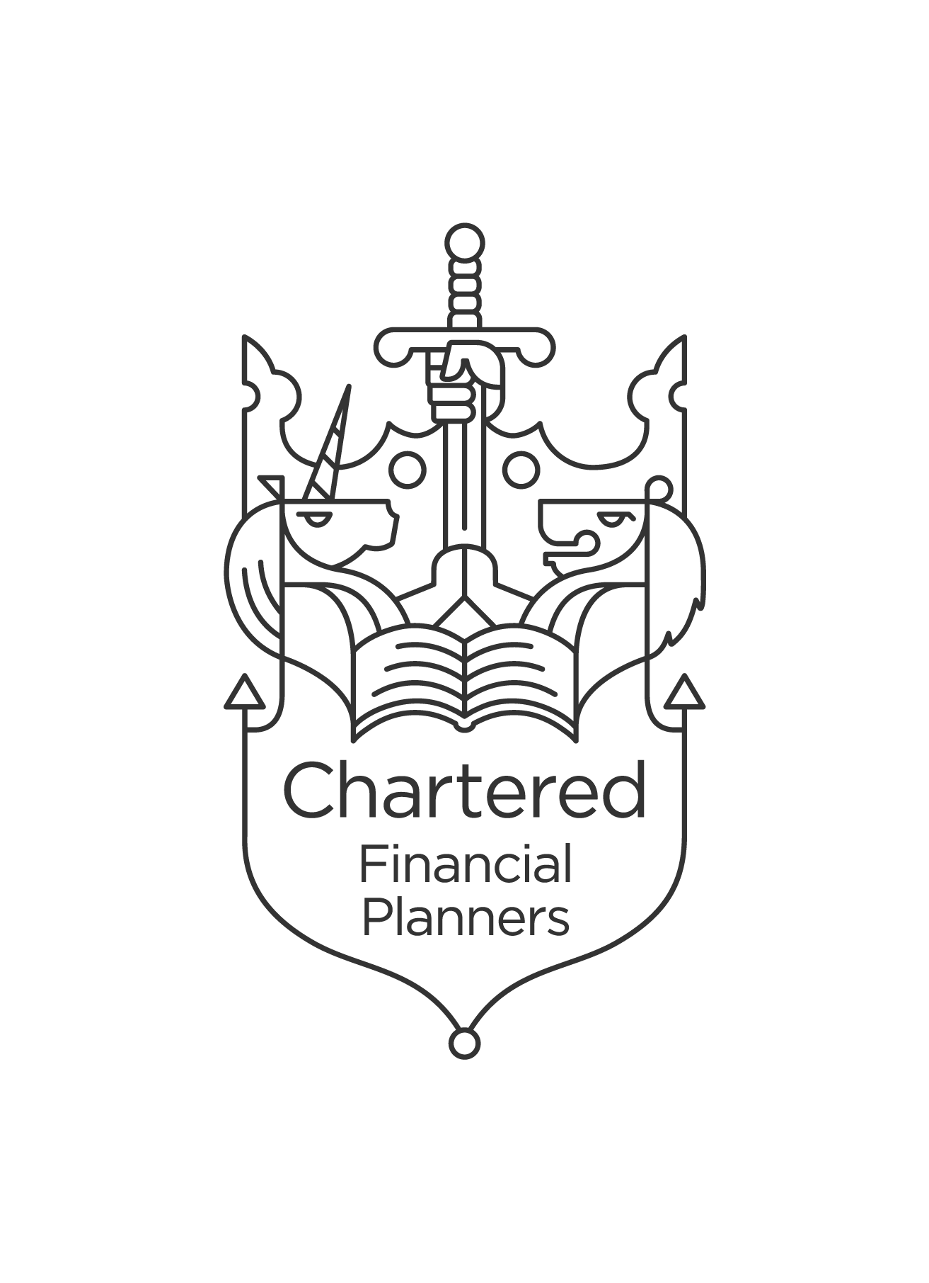


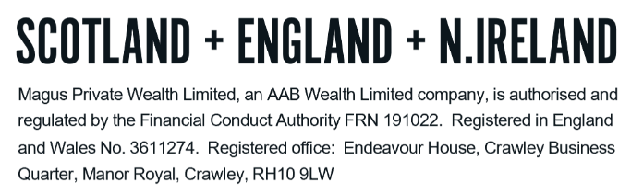
TECHNICAL NOTES – COLLECTIVE INVESTMENTS

What are collective investments?

Collective investments, also known as a General Investment Account (“GIA”), allow individuals to pool their resources to enable the scheme to invest in a wide spread of investments at lower costs than could have been achieved by individual acting on their own. Investors buy and sell units or shares in the scheme and not the underlying investments of the fund.

The primary aim of this investment is to provide capital growth, which is in excess of that which could be achieved in a bank or building society. The most significant factor affecting the ultimate investment return is how well the fund performs. This fund will be managed for you by a professional fund manager.

This is intended as a long-term investment and therefore requires sufficient time to grow. Should you withdraw your investment during the early years of the plan (typically within the first 5 years) you may not get back the full amount invested.

Advantages of Collective Investments

- Collective investments offer a good way to invest small sums of money, because the investors’ cash can be pooled into a much larger fund.

- Professional fund managers make the underlying investment decisions.

- An investor can achieve a balanced portfolio at a modest cost because the fund managers will invest in a spread of investments.

- Collective investments offer the ability to pursue particular objectives or specialise in particular markets that an investor might otherwise be unable to access.

- The individual investor’s risk is reduced by the wide spread of investments in the underlying portfolio.

How Collective Investments Work

- Units or shares are sold to investors, each unit representing a small but equal fraction of a portfolio of perhaps 50 or 100 different share holdings.

- These are open-ended. Units or shares can be created or issued when investors invest and cancelled when investors dispose of their holdings by selling them back to the fund manager ensuring maximum flexibility.

Taxation

Income (dividend or interest) from these funds can be distributed or accumulated within the fund.

UK individuals have a dividend allowance of £500 each tax year. The rate of tax for dividends above the £500 allowance is 8.75% for basic rate taxpayers, 33.75% for higher rate taxpayers and 39.35% for additional rate taxpayers.

There is a personal savings allowance available to offset savings income and this allowance is £500 for higher rate taxpayers and £1,000 for basic rate taxpayers. If your distributions fall into these categories there will be no tax to pay. An additional rate taxpayer will not be eligible for this allowance.

Capital Gains Tax (“CGT”)

CGT is a tax on the profit when you sell (or ‘dispose of’) something (an ‘asset’) that has increased in value. It is the gain you make that is taxed, not necessarily the amount of money you receive.

Each individual has the benefit of an annual exemption (currently £3,000) and as long as the gain together with any other gains you may have in the same tax year is less than the allowance, there is no tax to pay. On death, any gains are usually reset to zero at the date of the individual’s death.

Chargeable assets are defined as:

- Most personal possessions worth £6,000 or more, apart from your car
- Property that is not your main home
- Your main home and/or garden if you’ve let it out or exclusively used it for business
- Excess large garden plots sold off separately
- Investment that are not in an ISA
- Business assets

Any gain in excess of the annual allowance will be taxed at a rate of 18% if, after adding the taxable gain to your taxable income in the relevant tax year, the total falls within the basic rate income tax band. A tax rate of 24% applies to gains or parts of gains that exceed the basic rate income tax band.

Please be aware that the Magus portfolios contain income units, which produce taxable income. Providers will issue a consolidated tax voucher each year to assist you in making the correct tax return. This should be given to your accountant for tax return purposes.

Magus are not qualified tax accountants. You should seek advice from a qualified accountant if you require a full CGT calculation and tax projection.

Reporting capital gains to HMRC

Our understanding is that reporting of capital gains to HMRC is required if:

- The total gains over the tax year exceed the capital gains allowance of £3,000, or
- The proceeds from sales of assets are above £50,000 and you currently submit a tax return

Capital losses

A capital loss can be offset against capital gains of the same tax year but cannot be carried back against gains of earlier years. If you have unused capital loss, this can be carried forward indefinitely against gains of future years.

It is important this loss is reported to HMRC within 4 years after the end of the tax year that you disposed of the asset to avoid losing the ability to offset the loss against future gains

DO NOT REMOVE THIS LINE – DELETE THE TEXT ONLY


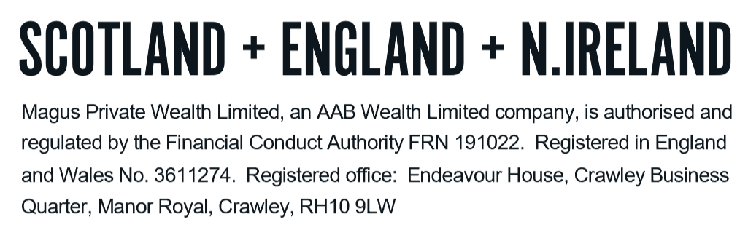
Tel: +44 (0)203 176 5888
magus.servicing@aabwealth.uk
www.aabwealth.uk

