




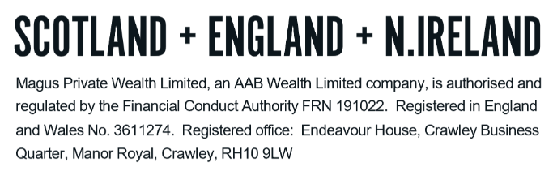
GLOSSARY - PROTECTION

We understand how confusing financial services can be. There is a lot of ‘jargon’ around and we want to ensure you are comfortable with the various terms that you may come across and that may be included in our report. The following are some of the key terms and a ‘plain English’ explanation, but do please let us know if there is anything else that is unclear to you.

A
Accidental death cover | An additional option that can be added to a life policy. If included, this will ensure a payment is made if death is caused by an accident.
Any occupation | A claim made on an income protection policy if the life assured is unable to do any kind of paid work, rather than the job they were doing prior to the claim.

B
Buy back option | Provides the option to buy back life insurance cover after a critical illness claim is made.

C
Critical illness cover (“CIC”) | Building in CIC means the sum assured would be paid out in the event of you contracting one of a number of critical illnesses. You should note that the critical illnesses covered are predetermined by the provider and you should refer to the ‘key features’ document for a full list of the illnesses covered. If the plan pays out on a critical illness, it will then cease and there will be no cover left, either life or critical illness.
Conversion | Provides the option to switch to another type of insurance - offering the same level of cover - without any disclosure of further medical information.

D
Deferred period | The period of time before any benefit will be paid out to you.

G
Guaranteed insurability | An option that can be added to enable you to increase your cover at any time, without the need to have a further medical or to disclose any further information.
Guaranteed premium | The premium is guaranteed to remain the same over the term of the policy unless the amount of cover is altered, or indexation is selected.

I
Income protection | An insurance policy which provides a replacement income in the event that you are unable to work due to a prolonged illness.
Indexation | Indexation allows you to maintain your level of cover in real terms by increasing it in line with an index, such as RPI (Retail Price Index) or NAEI (National Average Earning Index), or at a set percentage. This means that each year your sum assured would increase, ideally to match the cost of living and reduce any inflation risk. To provide this increasing cover, your premium would also increase.

L
Life assured | The person whose life is insured by way of cover. If this person passes away or becomes ill, the benefits will be paid out.
Life cover | Provides a tax-free payment if you die during the term of the policy.

O
Own occupation | A claim made on an income protection policy if the life assured is unable to continue doing their own job.

R
Reviewable premium | After an initial guaranteed period, the premium is reviewed periodically and could increase or decrease.

S
Suited occupation | A claim made on an income protection policy if the life assured is unable to continue doing their own job, or another job that they are suited to from their past experience and training.

T
Term assurance | Term assurance is life insurance that pays a specified amount upon your death and it set to run for a specific term.
Terminal illness cover | If your plan includes terminal illness cover and you are diagnosed with a terminal illness, and have less than 12 months to live, the insurance company will pay out the full sum assured upon diagnosis. If the plan pays out on a terminal illness basis, it will not then pay out again upon death.
Total permanent disability benefit | A payment made on total and permanent disability - usually defined by the life assured's inability to carry out their own occupation or perform a number of ‘activities of daily living’.

U
Unit-linked premium | The premium buys units in a unitised insurance fund and these units are regularly encashed to meet the cost of the insurance. Over time the policy may acquire a surrender value or premiums may need to be increased to maintain the level of cover.

W
Whole of life | A life insurance policy which is guaranteed to remain in force for your entire lifetime, provided the premiums are paid.
Waiver of premium | Wavier of premium aims to ensure that, in the event of you being unable to work due to an accident or ill health for longer than a pre-determined period of time, the insurance company will pay the policy premiums on your behalf.
Working task | A claim on an income protection policy can only be made if the life assured is unable to perform certain general work-based activities.

DO NOT REMOVE THIS LINE – DELETE THE TEXT ONLY


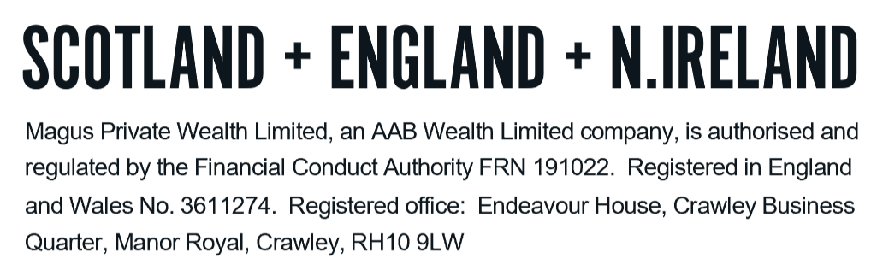
Tel: +44 (0)203 176 5888
magus.servicing@aabwealth.uk
www.aabwealth.uk

