




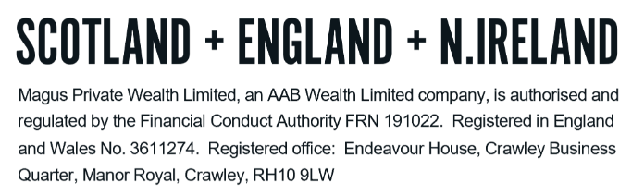
GLOSSARY - PENSIONS

We understand how confusing financial services can be. There is a lot of ‘jargon’ around and we want to ensure you are comfortable with the various terms that you may come across and that may be included in our report. The following are some of the key terms and a ‘plain English’ explanation but do please let us know if there is anything else that is unclear to you.

A
Accumulation Units | A type of fund where any income generated (dividends/savings interest) is used to purchase more units in the fund. An accumulation unit will have ‘Acc’ at the end of the fund name. This differs from Income Units.
Allocation rate | The insurer may decide to allocate more or less than the contribution to the plan, depending on the facilities of the scheme.
Annual Management Charge (“AMC”) | The charge listed for managing an investment fund. This charge usually only covers the management of the fund with additional expenses and transactional costs listed separately. A fund will typically list a Total Expense Ratio (“TER”) or Ongoing Charges Figure (“OCF”) to combine the AMC with the additional costs.
Annual Allowance | The limit for pension contributions that can be made to a pension in a given tax year. Contributions that exceed the annual allowance and which do not have Carry Forward to use attract a tax charge on the excess at the rate of the individual’s marginal income tax rate.
Annuity | The historically common way of taking retirement benefits in the form of exchanging the value of unused pension funds in return for a taxable lifetime income.
Asset allocation | The selection of various assets within your investment portfolio. The allocation of your portfolio will not only determine the level of risk you are exposed to but will also, to a very large part, determine the potential returns. This is the basic principal that for every risk level there is an optimal combination of asset classes, which will maximise returns.
Auto enrolment | The name given to the process of ensuring all eligible employees are automatically made members of a pension scheme that they and their employer contribute to. While not every worker is automatically enrolled, the vast majority are and will benefit from employer contributions by remaining members.  While it is possible to opt out of these schemes, it is not generally advisable to do so, except in limited circumstances (as the employee would be giving up valuable employer contributions).

B
Bid/offer spread | This is essentially the difference between the cost of buying units from the insurer and the cost of selling them back, and is applied as an initial charge on contributions.

C
Capacity for Loss | The ability to absorb falls in the value of your investment. If any loss of capital would have a materially detrimental effect on your standard of living, this would be an important factor in determining the level of investment risk you are able to take.
Carry Forward | The ability to bring unused Annual Allowances from the previous three tax years into the current tax year. Using carry forward will allow an individual to exceed the annual allowance in the current tax year without incurring a tax charge for doing so.
Charges | Providers can take charges in a number of ways from your plans. Also see individual listings for Bid/offer spread; Total Expense Ratio (“TER”); Ongoing Charges Figure (“OCF”); Policy Fee; Platform fee; Investment Manager Charge (“IMC”); Allocation Rate; and Initial Units.

D
Defined benefits | A type of pension plan (final salary) in which an employer/sponsor promises a specified monthly benefit on retirement that is predetermined by a formula based on the employee’s earnings history, length of service and age.
Defined contribution | A type of pension plan (personal pension/stakeholder/SIPP) where the amount available at retirement is dependent on personal contributions and growth on the underlying funds. At retirement benefits can be taken through an annuity or through drawdown.

F
Flexi-access drawdown (“FAD”) | The name given for new drawdown plans entered into. Under FAD, there is no restriction on the amount of withdrawals that can be made from a pension fund.

G
Guaranteed minimum pension (“GMP”) | The GMP is the minimum pension which a United Kingdom occupational pension scheme has to provide for those employees who were contracted out of the state earnings- related pension scheme (“SERPS”) between 6th April 1978 and 5th April 1997. The amount is said to be 'broadly equivalent' to the amount the member would have received had they not been contracted out.

I
Incidental Charges | Extra costs payable to the fund manager in relation to, predominately, performance-related fees.
Income Units | A type of fund where the income generated (dividends/savings interest) is paid out to the investor directly or to the Platform cash account. An income fund will have ‘Inc’ at the end of the fund name.  This differs from Accumulation Units.
Initial Units | In the first few years of a plan, the insurer may purchase ‘initial/capital’ units, which are then deducted throughout the term of the policy to cover fees.
Inflation | The change in annual prices. This is commonly measured by government using one of two measures; the Retail Prices Index (“RPI”) or the Consumer Price Index (“CPI”). RPI measures certain types of cost escalation. CPI measure the monthly change in prices paid by consumers for everyday goods and services. CPI is the official measure of inflation in the UK.
Investment Manager Charge (“IMC”) | This comprises of the Ongoing Charge Figure (“OCF”) plus transaction costs.

L
Lifetime Allowance | This was the maximum amount of pension savings available before an additional tax charge is applied on the excess. A tax charge no longer applies on the excess. It was formally abolished from legislation from 6 April 2024.  There were a number of Lifetime Allowance protections that were available and can still be held and used as a reference for entitlement to the Lump Sum Allowance (“LSA”) and/or the Lump Sum and Death Benefit Allowance (“LSDBA”).  It is no longer possible to obtain any form of Lifetime Allowance protection.
Lump Sum Allowance (“LSA”) | There is a lifetime limit on the amount of PCLS an individual can have and this limit is the LSA.  The LSA in the current tax year is £268,275 (though this can be higher for people with transitional lifetime allowance protections).
Lump sum and death benefit allowance (“LSDBA”) | This allowance is the second replacement for the lifetime allowance and determines the availability of tax-free lump sums left on death before age 75.  The LSDBA is reduced during the individual’s lifetime by the amount of LSA that has been used.  The LSDBA is currently £1,073,100 (though it can again be higher for those with lifetime allowance protections).

O
Ongoing Charges Figure | This is the cost of managing the investment funds (the annual management charge - AMC) plus the additional underlying costs for the activity within the fund. This is the new term for what was previously known (and still quoted as) the total expense ratio (“TER”).

P
Pension | A type of tax wrapper that is primarily used to save for retirement. An individual using a pension can be granted tax advantages on contributions as well as the underlying investments made within the wrapper.
Pension Commencement Lump Sum (“PCLS”) | A tax-free cash payment available from a pension plan. The standard entitlement is 25% of the fund value (up to a lifetime total of £268,275 unless lifetime allowance protection and/or the pension in question has a protected entitlement to more PCLS).  The remaining 75% must be designated to drawdown or used to purchase an annuity.
Platform | A platform is designed to assist investors and their advisers with arranging transactions, reporting and administering an investment portfolio or pension arrangement. It provides a place to hold various plan types and the ability to easily access and view your financial plans online.
Platform Fee | A charge applied by the platform for administering the platform account. This is usually expressed as an annual percentage of the assets held on the platform. The charge itself is usually deducted on a monthly basis.
Policy Fee | A charge applied by the policy. This can either be on a percentage basis (as with Platform fee above) or it can be expressed as a fixed monetary cost.

R
Relevant Benefit Crystallisation Event (“RBCE”) | A RBCE is the payment of a relevant lump sum and/or lump sum death benefit. A RBCE reduces future entitlement to the lump sum allowance (“LSA”). The main RBCEs are:  - Payment of a PCLS  - Payment of a UFPLS (the tax-free component)  - A trivial commutation lump sum (the tax-free component)  - A winding-up lump sum (the tax-free component)
Risk | The general principle of risk and reward is, the greater the risk, the greater the potential reward. In terms of ‘investment risk’, this means the more risk you expose your capital to, the more chance you have of losing part, or even all of it.

S
Self Investment Personal Pension (“SIPP”) | A type of personal pension which has a very flexible approach to investments and typically offers the widest investment options available in personal pensions.
Stakeholder pension | A type of personal pension that is required to accept a minimum level of regular contribution (£20 per month), provide a default investment fund for investors who do not want to select their own funds, and provide a cap on the charges that are applied.  The charges cap is 1.50% for the first 10 years and 1% thereafter.

T
Total Expense Ration (“TER”) | Much like the OCF, it provides a more complete picture of the total annual costs involved in running an investment. Total costs may include various fees (purchase, redemption, auditing) and other expenses.
Trading Costs | Commissions and other expenses relating to the trade of an investment/security.
Transactional Charges | Investment fund managers make transactions within the fund. The transactional charge is an estimate, based on prior transactions, of the annual cost the transactions incur for investors.

U
Uncrystallised Fund Pension Lump Sum (“UFPLS”) | An alternative way of accessing a pension fund.  The value of a pension policy (full value or partial if the provider permits) can be withdrawn as a lump sum payment. 25% of the payment will be tax-free with 75% added to your income for the year and taxed accordingly. Pension funds need not be designated to drawdown or annuity purchase under this option.

W
With profits | These are investment funds offered by insurance companies. The fund is managed and the costs of running it are deducted from the fund. What is left over, the profit, is paid out in the form of bonuses. Profits in good years can be retained to provide a return in negative years. This makes the structure complex, difficult to understand the exact asset allocation and difficult to determine the true costs of the fund.
Wrap | A Wrap is an internet-based account offering a single solution for multiple portfolio transactions and tax wrappers. It offers the ability to buy and sell investments, switch into different asset classes, reinvest or take dividends and income, all from a single account.

DO NOT REMOVE THIS LINE – DELETE THE TEXT ONLY


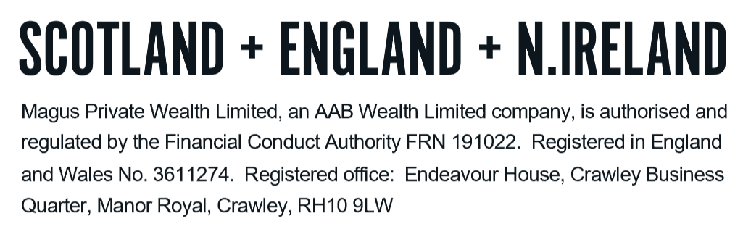
Tel: +44 (0)203 176 5888
magus.servicing@aabwealth.uk
www.aabwealth.uk

