
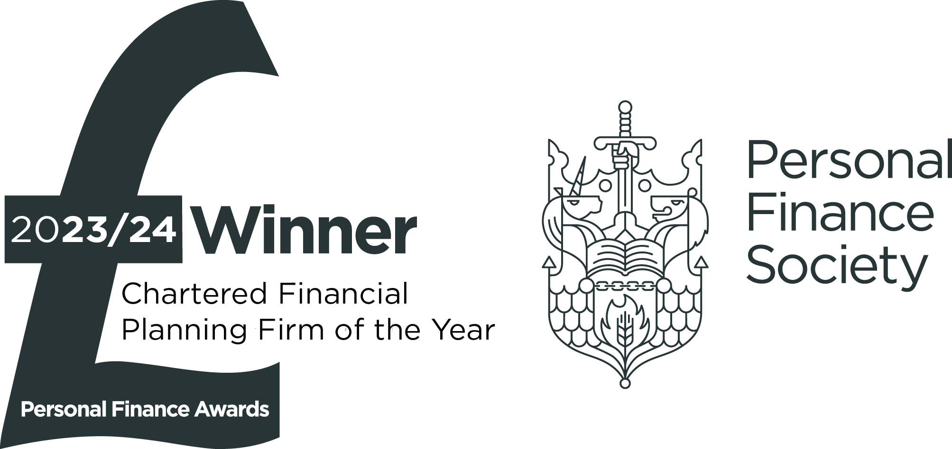
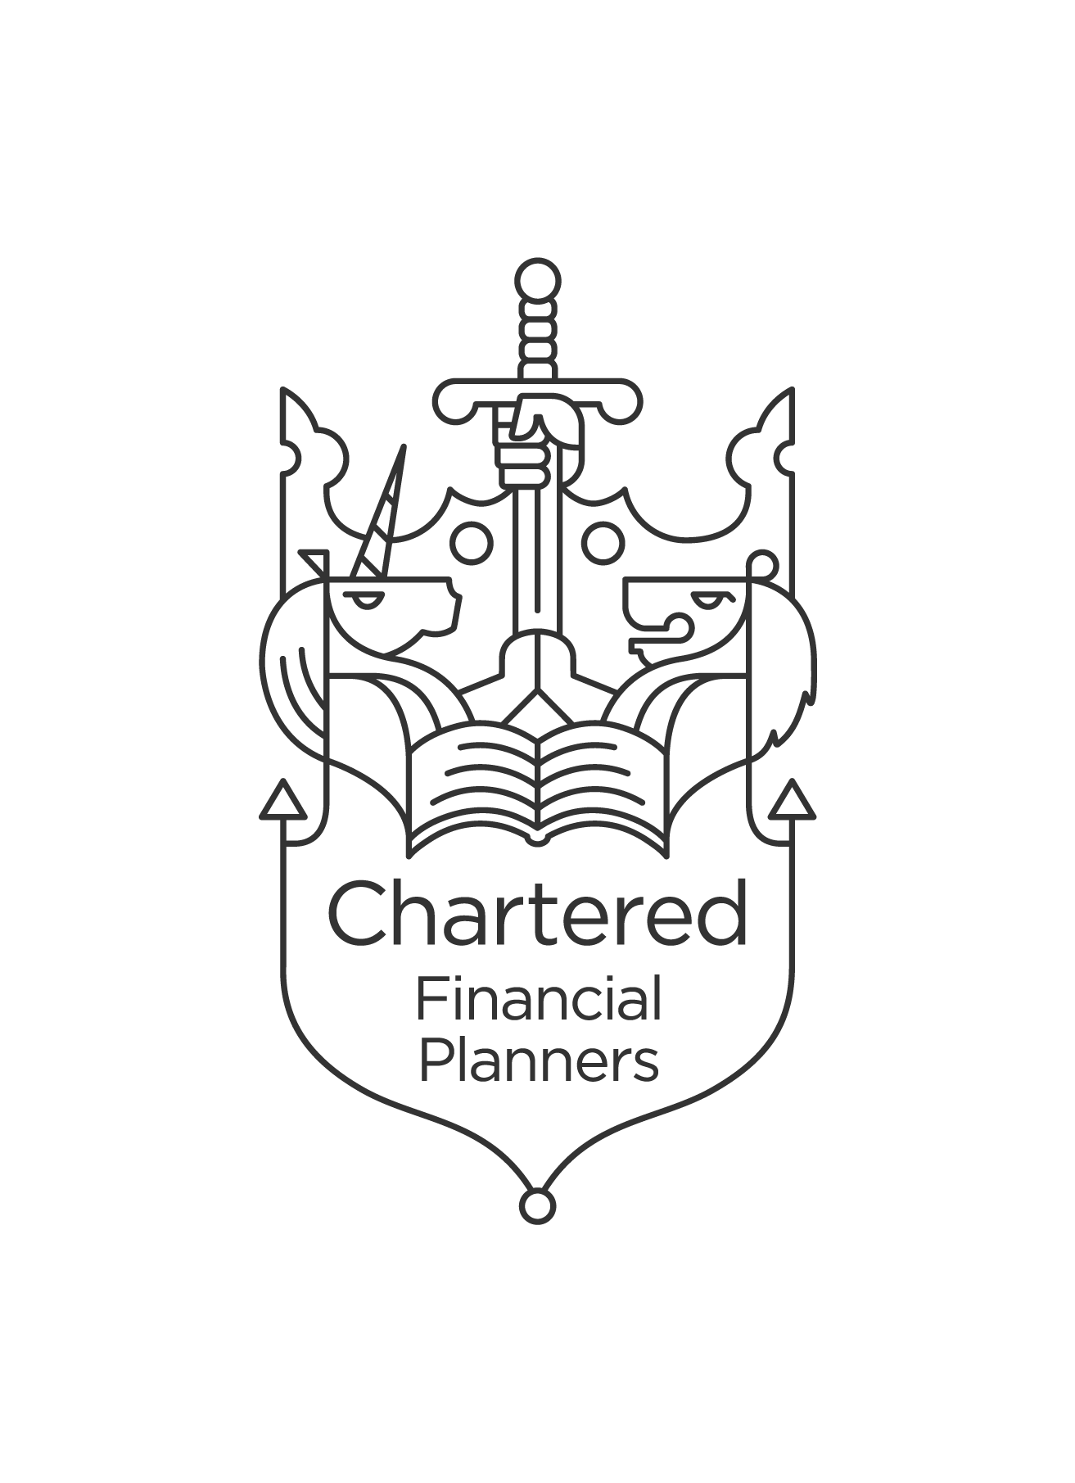


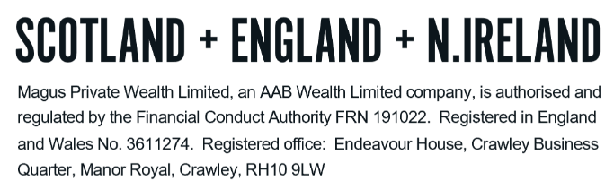
GLOSSARY - INVESTMENTS

We understand how confusing financial services can be. There is a lot of ‘jargon’ around and we want to ensure you are comfortable with the various terms that you may come across and that may be included in our report. The following are some of the key terms and a ‘plain English’ explanation but do please let us know if there is anything else that is unclear to you.

A
Accumulation Units | A type of fund where any income generated (dividends/savings interest) is used to purchase more units in the fund. An accumulation unit will have ‘Acc’ at the end of the fund name. This differs from Income Units.
Allocation rate | The insurer may decide to allocate more or less than the contribution to the plan, depending on the facilities of the scheme.
Annual Management Charge (“AMC”) | The charge listed for managing an investment fund. This charge usually only covers the management of the fund with additional expenses and transactional costs listed separately. A fund will typically list a Total Expense Ratio (“TER”) or Ongoing Charges Figure (“OCF”) to combine the AMC with the additional costs.
Asset allocation | The selection of various assets within your investment portfolio. The allocation of your portfolio will not only determine the level of risk you are exposed to but will also, to a very large part, determine the potential returns. This is the basic principal that for every risk level there is an optimal combination of asset classes, which will maximise returns.

B
Bid/offer spread | This is essentially the difference between the cost of buying units from the insurer and the cost of selling them back, and is applied as an initial charge on contributions.

C
Capacity for Loss | The ability to absorb falls in the value of your investment. If any loss of capital would have a materially detrimental effect on your standard of living, this would be an important factor in determining the level of investment risk you are able to take.
Capital Gains Tax (“CGT”) | The tax payable on any gains realised above the CGT exemption amount of £3,000. The rate of tax applied is dependent on personal circumstances (see technical notes).
Charges | Providers can take charges in a number of ways from your plans. Also see individual listings for Bid/offer spread; Total Expense Ratio (“TER”); Ongoing Charges Figure (“OCF”); Policy Fee; Platform fee; Investment Manager Charge (“IMC”); Allocation Rate; and Initial Units.

G
General Investment Account (“GIA”) | The name of an investment wrapper. Unlike an Individual Savings Account (“ISA”) there can be tax to pay on dividends accrued and Capital Gains realised within a GIA. There are no legal restrictions on the amount invested or withdrawn from a GIA. Some GIAs can hold both Unit Trust and OEICs within this wrapper.

I
Incidental Charges | Extra costs payable to the fund manager in relation to, predominately, performance-related fees.
Income Units | A type of fund where the income generated (dividends/savings interest) is paid out to the investor directly or to the Platform cash account. An income fund will have ‘Inc’ at the end of the fund name.  This differs from Accumulation Units.

I
Individual Savings Account (“ISA”) | The tax-efficient wrapper where any Capital Gains and/or dividends can be received free of tax. There is a maximum contribution limit of £20,000 for the 2025/26 tax year. These products may also be abbreviated as New Individual Savings Accounts (“NISAs”). There is an ISA available for under 18’s known as a Junior ISA (“JISA”).
Initial Units | In the first few years of a plan, the insurer may purchase ‘initial/capital’ units, which are then deducted throughout the term of the policy to cover fees.
Inflation | The change in annual prices. This is commonly measured by government using one of two measures; the Retail Prices Index (“RPI”) or the Consumer Price Index (“CPI”). RPI measures certain types of cost escalation. CPI measure the monthly change in prices paid by consumers for everyday goods and services. CPI is the official measure of inflation in the UK.
Investment Manager Charge (“IMC”) | This comprises of the Ongoing Charge Figure (“OCF”) plus transaction costs.

O
Ongoing Charges Figure | This is the cost of managing the investment funds (the annual management charge - AMC) plus the additional underlying costs for the activity within the fund. This is the new term for what was previously known (and still quoted as) the total expense ratio (“TER”).
Open ended Investment Companies (“OEICs”) | An open-ended investment company (OEIC), is a type of collective or pooled investment fund in the UK. Money from many investors is pooled together, and professional fund managers will buy shares in companies, government or corporate bonds and/or property and alternative investments on behalf of the fund.  An OEIC is open-ended in that there are no restrictions on the amount of money that can flow into the fund. Units are created and cancelled as investors contribute to and withdraw from the fund.

P
Platform | A platform is designed to assist investors and their advisers with arranging transactions, reporting and administering an investment portfolio or pension arrangement. It provides a place to hold various plan types and the ability to easily access and view your financial plans online.
Platform Fee | A charge applied by the platform for administering the platform account. This is usually expressed as an annual percentage of the assets held on the platform. The charge itself is usually deducted on a monthly basis.
Policy Fee | A charge applied by the policy. This can either be on a percentage basis (as with Platform fee above) or it can be expressed as a fixed monetary cost.

R
Risk | The general principle of risk and reward is, the greater the risk, the greater the potential reward. In terms of ‘investment risk’, this means the more risk you expose your capital to, the more chance you have of losing part, or even all of it.

T
Total Expense Ration (“TER”) | Much like the OCF, it provides a more complete picture of the total annual costs involved in running an investment. Total costs may include various fees (purchase, redemption, auditing) and other expenses.
Trading Costs | Commissions and other expenses relating to the trade of an investment/security.
Transactional Charges | Investment fund managers make transactions within the fund. The transactional charge is an estimate, based on prior transactions, of the annual cost the transactions incur for investors.

U
Unit Trust | A unit trust is similar to an Open Ended Investment Company (“OEIC”) and only differs in the fact it is governed by trust law rather than company law (as is the case with OEICs).

W
With profits | These are investment funds offered by insurance companies. The fund is managed and the costs of running it are deducted from the fund. What is left over, the profit, is paid out in the form of bonuses. Profits in good years can be retained to provide a return in negative years. This makes the structure complex, difficult to understand the exact asset allocation and difficult to determine the true costs of the fund.
Wrap | A Wrap is an internet-based account offering a single solution for multiple portfolio transactions and tax wrappers. It offers the ability to buy and sell investments, switch into different asset classes, reinvest or take dividends and income, all from a single account.

DO NOT REMOVE THIS LINE – DELETE THE TEXT ONLY


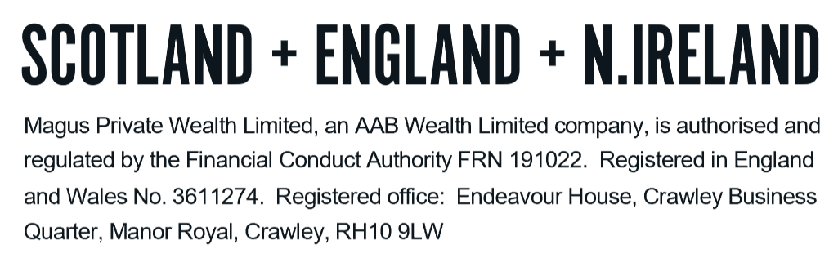
Tel: +44 (0)203 176 5888
magus.servicing@aabwealth.uk
www.aabwealth.uk

