




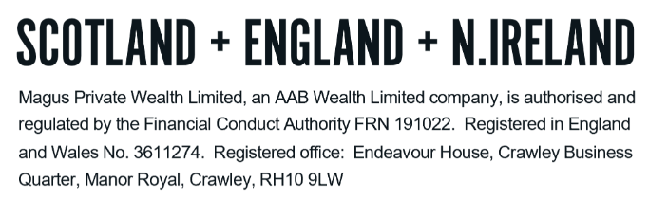
GLOSSARY - DRAWDOWN

We understand how confusing financial services can be. There is a lot of ‘jargon’ around and we want to ensure you are comfortable with the various terms that you may come across and that may be included in our report. The following are some of the key terms and a ‘plain English’ explanation, but do please let us know if there is anything else that is unclear to you.

A
Annuity | Historically the most common way of taking retirement benefits in the form of exchanging the value of unused pension funds in return for a taxable lifetime income.

C
Capped drawdown | A form of drawdown where the maximum income that can be drawn is subject to the Government Actuary Department (“GAD”) limit. It is not possible to start a new Capped Drawdown plan, though existing policies can continue and have further funds designated to them.
Critical yield A | Represents the growth rate needed by the drawdown fund to provide and maintain an income equal to that obtainable under an open-market annuity now, as well as at a selection of future ages.
Critical yield B | Represents the growth rate needed by the drawdown fund to provide an annuity that matches the level of withdrawal being taken (rather than the amount available from an annuity at the outset).

F
Flexi-access drawdown (“FAD”) | The name given for all new drawdown plans entered into. Under FAD, there is no restriction on the amount of withdrawals that can be made from a pension fund.

L
Lifetime allowance | This was the maximum amount of pension savings available before an additional tax charge is applied on the excess. It was formally abolished from legislation from 6 April 2024.  There were a number of Lifetime Allowance protections that were available and can still be held and used as a reference for entitlement to the Lump Sum Allowance (“LSA”) and/or the Lump Sum and Death Benefit Allowance (“LSDBA”).  It is no longer possible to obtain any form of Lifetime Allowance protection.
Lump sum allowance (“LSA”) | There is a lifetime limit on the amount of PCLS an individual can have and this limit is the LSA.  The LSA in the current tax year is £268,275 (though this can be higher for people with transitional lifetime allowance protections).
Lump sum and death benefit allowance (“LSDBA”) | This allowance is the second replacement for the lifetime allowance and determines the availability of tax-free lump sums left on death before age 75.  The LSDBA is reduced during the individual’s lifetime by the amount of LSA that has been used.  The LDBA is currently £1,073,100 (though it can again be higher for those with lifetime allowance protections).

M
Money purchase annual allowance (“MPAA”) | The reduced amount an individual can contribute to a pension each tax year without being subject to an excess tax charge. This is currently £10,000 (reduced from the standard £60,000) and an individual becomes subject to this when they flexibly access income from a pension.  Purchasing a lifetime annuity with pension funds does not cause the MPAA to apply.

N
Nominee drawdown | A drawdown pension inherited from the member by the nominated individual(s). This is available to the nominee(s) tax-free if death of the member was prior to 75, or taxable at their marginal income tax rate if death of the member was after 75.

P
Pension commencement lump sum (“PCLS”) | A tax-free cash payment available from a pension plan. The standard entitlement is 25% of the fund value (up to a lifetime total of £268,275 unless lifetime allowance protection and/or the pension in question has a protected entitlement to more PCLS).  The remaining 75% must be designated to drawdown or used to purchase an annuity.

R
Relevant benefit crystallisation event (“RBCE”) | A RBCE is the payment of a relevant lump sum and/or lump sum death benefit. A RBCE reduces future entitlement to the lump sum allowance (“LSA”). The main RBCEs are:  - Payment of a PCLS  - Payment of a UFPLS (the tax-free component)  - A trivial commutation lump sum (the tax-free component)  - A winding-up lump sum (the tax-free component)

S
Self invested personal pension (“SIPP”) | A type of personal pension which has a very flexible approach to investments and typically offers the widest investment options available in personal pensions.
Successor drawdown | The drawdown pension inherited by an individual(s) of the nominee drawdown pension holder. The tax on access for the successor is based on the age at death of the nominee.

U
Uncrystallised fund pension lump sum (“UFPLS”) | An alternative way of accessing a pension fund.  The value of a pension policy (full value or partial if the provider permits) can be withdrawn as a lump sum payment. 25% of the payment will be tax-free with 75% added to your income for the year and taxed accordingly.  Pension funds need not be designated to drawdown or annuity purchase under this option.

DO NOT REMOVE THIS LINE – DELETE THE TEXT ONLY


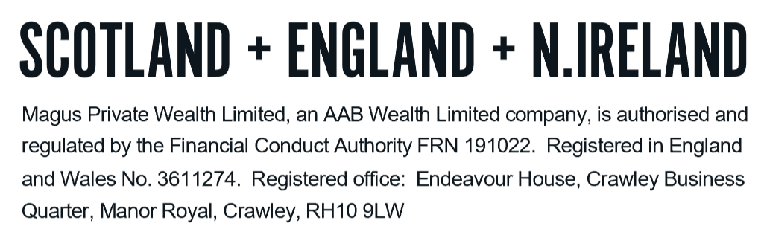
Tel: +44 (0)203 176 5888
magus.servicing@aabwealth.uk
www.aabwealth.uk

